Step 3

Starting this subject late I didn’t really have much of a chance to even think about what type of company I wanted for my assignment. So, I was quite intrigued when I found out my company was RELX. I had never heard of this company before so that was slightly daunting to me. Yet, I felt ready to devote my time into diving deeper into the company find out what it is all about. I guess the most worrying thing about this company for me was that it wasn’t an Australian one. Looking back at it now it doesn’t worry me what so ever that it wasn’t one.

Scanning over the RELX’s website and annual reports I discovered it was a publishing company that provides information-based analytics and decision tools for professional and business customers. Also turns out that I have actually used one of their legal data bases, LexisNexis in the past. When I found this out, it helped me to realise what the company was all about. The Chief Executive Officer Erik Engstrom also made the statement ‘Our goal is to help our customers make better decisions, get better results and be more productive.’ Which stood out to me because with my own past experience with LexisNexis I was able to see first-hand how they actually help people be more productive. Yet, they don’t only help provide information for the legal industry but also 3 other segments which include Scientific, Technical & Medical; Risk & Business Analytics; and Exhibitions.

Before jumping into the annual reports, I wanted to explore the website and see what it is RELX is capable of doing and see what type of involvement it had with giving back to society. I discovered that RELX has played a large role in The Lancet Campaign to End Preventable Stillbirths. They have done this by allowing/supporting sciences most prestigious journal The Lancet to be able to record all information necessary to do with still births and other issues to allow people to make better decisions to do with their health. The Lancet’s goal is to publish the best science to improve the health of people world-wide. This campaign alone made me realise how important databases can be because without a place or resource that allows you to upload beneficial information and share it with the world, how else would science and humanity improve? With further research, I found that RELX has expanded to help make a sustainable planet. They have done this by setting up a date base called RELX Group Sustainable Development Goals (SDGs) Resource Centre (the homepage can be accessed here). The SDGs main mission is to support the UN’s agenda that is including the UN’s 17 goals and 169 targets. I must admit I was confused on how a company like RELX SDG could help the UN but once reading it I was able to see that the company is able to launch articles and reports that assist readers in gaining more knowledge on how others are trying to reach these goals and how they can help as well.
Another Video that I just found interesting was an interview Nick Luff the Executive Director had with Sky News about if the political change in the UK had any effect on the business the Nick went on to say that whether the UK was in or out of the EU it wouldn’t affect the as much as RELX is a company that is able to adopt change.
Once I knew some background information on RELX I was ready to dive into the pages and pages of annual reports. The annual report for 2018 started with a summary from the chairperson, Sir Anthony Habgood who briefly covered how they had achieved their goals in terms of revenue and operating profits. It was read that revenue had a 4% growth and operating profits grew 6%. These figures being the first I have come across, I personally thought they were quite good for a company that big to still be improving that much. Then I continued to read the Chairpersons blurb on Corporate responsibility where I was taken aback by the first line ‘We take our commitment to human rights seriously as evidenced by our Modern Slavery Act Statement, which outlines how we work to avoid slavery and trafficking in our direct employment and in our supply chain.’ I never really thought that a company of RELX’s size would need to worry about, nor care about slavery or trafficking in their direct employment but reality is it is a possibility. Overall, I really just found it refreshing to know that there are still company’s out there fighting to create a safe and ethical work environment. The Chief Executor Erik Engstrom, also reiterated a bit of what he the Sir Habgood had said but he also went over their goals as a company which is to focus on evolving the fundamentals of the business to improve the businesses profile and the quality of earnings.
The annual report then breaks down into summaries of the company’s four categories of databases that RELX publishes. Below I have broken down each segment and noted the most interesting and important points that I extracted from the annual report.
Scientific, Technical & Medical
- RELX is the parent organisation for Elsevier which is a Dutch information and analytics company and one of the world's major providers of scientific, technical, and medical information. They have principal operations set out all across the world. Such as New York, Rio de Janeiro and Tokyo just to name a few. It has 7,900 employees and serves customers in around 180 countries.
- Revenue has increased from £2,473m in 2017 to £2,538m in 2018. The bulk of the revenue came from North America (44%), 24% from Europe and 32% form he rest of the world.
- Subscription sales generated 74% of revenue, transactional sales 24% and advertising 2%.
- Elsevier journals have at some point featured articles by 183 of 184 science and economics Nobel prize winners since 2000
- Most of this section was based on how well Elsevier had done and how well done to be where they are today.
- Below shows the number of different scientific databases that RELX provides.
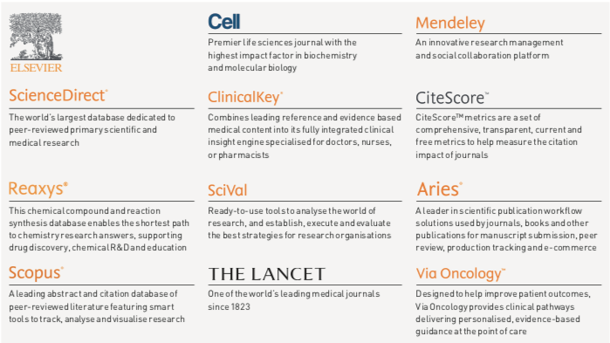
- Risk & Business Analytics
- This segment helps provide customers with advanced technology and algorithms to assist them in evaluating and predicting risk and enhancing operational efficiency.
- This division has 8,700 employees and serves customers in more than 170 countries.
- Revenues for the year ended 31 December 2018 were £2,117m, compared with £2,073m in 2017.
- One of RELX’s services Cirium automate the process of matching trips to waivers, making it easier and quicker for agents to find waiver details and understand if a traveller’s flight qualifies.
- 30% reduction in time spent resolving a traveller’s disrupted flight using Cirium’s services
- London’s version of Australia’s buying and selling site ‘Gumtree’ has started to use RELX’s Threat Metrix which is able to detect new users who may be using stolen a identity data, obfuscating their location or attempting to sign up for multiple accounts from the same device.
- This has enabled Gumtree to increase their fraud detection rate by 84%.
- To the right it shows the number of different Risk & Business Analytics databases that RELX provides.

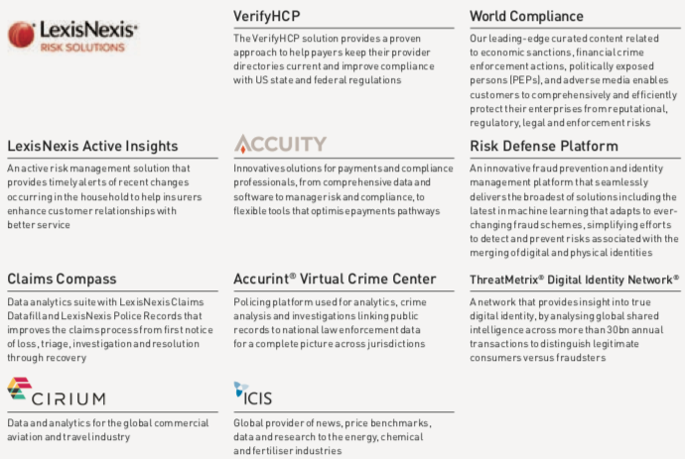

Legal
- The Legal division looks to help lawyers win cases, manage their work more efficiently, serve their clients better and grow their practices.
- LexisNexis Legal & Professional, RELX’S number one database is headquartered in New York and has other principal operations around the world. There are 10, 500 employees worldwide and serves customers in more than 130 countries.
- Revenue has dropped in 2018 compared to 2017, £1,618m £1,686m respectively.
- Subscription sales generated 77% of revenue and transactional sales 23%
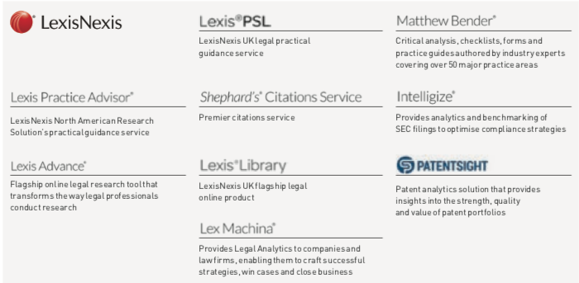
- Lexis Nexis is always looking to better itself and continues to be supported by RELX because this year in Canada, LexisNexis enhanced Lexis Advance Quicklaw by incorporating advanced data visualisation with the introduction of Search Maps .
- Below shows the number of different Legal databases that RELX Provides.

Exhibitions
- RELX assists exhibitions in generating customers billions of dollars by combing face-to- face with data and digital tools to help customers learn about markets, source products and complete transactions.
- RELX’s exhibitions attract more than 7 million participants.
- Reed Exhibitions had headquarters in London and other principal offices across the world.
- Contains 4,200 employees worldwide and its portfolio event serves 43 industry sectors. Revenue increased from £1,109m in 2017 to £1,219m in 2018.
- Like the previous segments North America brings in the majority of the revenue (44%)
- Below shows the number of different Exhibition databases and events that RELX supports.
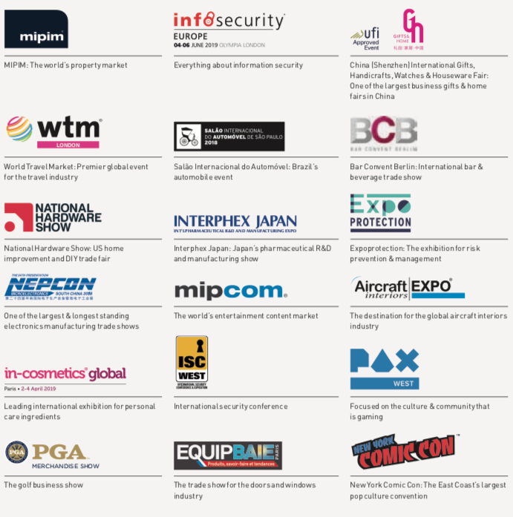
That was only just the basics of what each segment has to offer which allows readers to get some sort of idea of what RELX is all about. Moving on however, I found myself coming across some key financial highlights which I have printed down below
- Underlying revenue growth of 4%
- Underlying adjusted operating profit growth of 6%
- Reported operating profit £1,964m (£1,905m)
- Adjusted EPS growth at constant currency up 7%; in sterling, up 6% to 84.7p
- Reported EPS 71.9p (81.6p)
- Full-year dividend up 7% to 42.1p
- Strong financial position and cash flow; cash flow conversion at 96%

Now I am not too good at understanding all these financial terms for example even the concept of underlying revenue I don’t understand. If I break it down I know what revenue which is income. But, when I read the word underlying I think of the word hidden. So, I did a quick google search to see what it means and the Business Dictionary helped come to the conclusion that underlying revenue means measuring profit that is based on normal accounting cycle events that exclude rare circumstances or one-time events. Once I came to this realisation, the term made much more sense. As I was able to see it as basic common sense, that a company would need to exclude anomalies so interested parties would be able to get a better understanding of where the business stands financially.
The other abbreviation I was unsure with was EPS. Once I googled what it meant it instantly made sense and I didn’t know how I didn’t pick it up. So, EPS = Earning Per Shares means how much money a company is making in profits per year. It went on to say that there is an equation to working it out. It is calculated by subtracting preferred dividends from net income and dividing by the weighted average. It will still take me a while to get my head around this equation But at least I know why it is of importance.
I could go on for days about all the things that I can draw out of the annual report and the businesses website but I don’t want to put anyone to sleep just yet.
Links to Annual Reports
- 2018 Annual Report
- 2017 Annual Report

